**Training Guide**

**Adorama Customer Service**

**R**

**E**

**T**

**U**

**R**

**N**

**P**

**R**

**O**

**C**

**E**

**S**

**S**

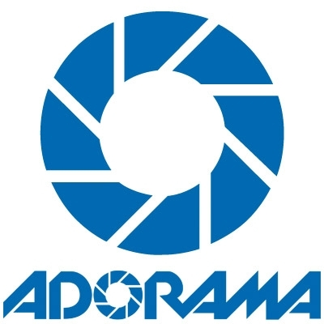

# Training Agenda

* Return and Exchange Policy
  + New Items
  + Used Equipment
  + Amazon.ca Return Policy
  + Drop shipped Return Policy
  + International Return Policy
* Defective Return (ITEM)
  + Normal Defective return
  + Drop-shipped
  + EBay orders
  + Non-Returnable Products
  + Downloadable Software Issue
* Defective Return (PART)
* NLN Return
  + Non-returnable items (Once opened)
  + Non-returnable items
  + Return with Restocking fee
* Past 30 Day Defective Return (Warranty)
  + Adorama House brand
  + Not House Brand but under Adorama Warranty
  + Used Equipment
* Refund Status Inquiry
  + PayPal funded orders
    - PP Pending
  + 3rd party orders
    - New Egg Credit
  + Orders funded by GC/CP
  + FA to funding source
* Refund Status - Reshipment Order

**Return and Exchange Policy**

**[All items except Used Equipment]**

For the first 30 days from the delivery date, we allow customers to return the merchandise to us for a refund or exchange. If the item was purchased in the store, customer has only 30 store days to return it.

No RMA number is required, we provide customer a link to download a Return Merchandise Form which they fill out and include in the return along with a copy of the original invoice.

Returned or exchanged products must: Be in brand-new, mint condition. Have all original manufacturers packaging, materials and accessories, including instruction booklets, packing inserts, and blank warranty cards.

The original manufacturer's packaging should be enclosed within an outer shipping box. Merchandise missing the original Universal Product Code (UPC) cannot be returned. If Mail-in-Rebate was claimed the product may no longer be returned, if it is defective, warranty must be handled with manufacturer.

The return address is:   
Order processing  
7 Slater Drive  
Elizabeth, NJ 07206

We do not cover or credit the return shipping cost (cost to send an item back to us) if the customer no longer want the item. If the customer will return the item because there is an issue with the product, we will cover the return shipping by sending a prepaid UPS return label.

We ask customers to allow up to 2-3 business days after we receive the package for the return/exchange/refund to be processed.

We are not allowed to process a reshipment or exchange for orders made through a 3rd party vendor except for eBay. Our contract with them requires that each purchase be a separate transaction. Therefore each return will be refunded.

**[Used Equipment]**

We allow returns for used equipment 30 days from the day it was delivered. If the item was purchased in the store, customers can only return it within 14 store days.

No RMA number is required, we provide customer a link to download a Return Merchandise Form which they fill out and include in the return along with a copy of the original invoice.

The return address is:   
Order processing  
7 Slater Drive  
Elizabeth, NJ 07206

We do not cover or credit the return shipping cost (cost to send an item back to us) if the customer no longer want the item. If the customer will return the item because there is an issue with the product, we will cover the return shipping by sending a prepaid UPS return label.

We ask customers to allow up to 3-4 business days after we receive the package for the return/exchange/refund to be processed.

We cannot process an exchange/reshipment if the order was placed through a third-party vendor except for eBay.

We are not allowed to process a reshipment or exchange for orders made through a 3rd party vendor except for eBay. Our contract with them requires that each purchase be a separate transaction. Therefore each return will be refunded.

**[Amazon.ca Return Policy]**

If the order was placed through Amazon.ca, the items need to be returned within Canada. BILSI has a location in Canada where customers will return the item to, and they will deliver it back to NJ. So instead of giving them the return address in NJ, this is the address we will provide them:

BILSI

Attn: Adorama Returns

4050A Sladeview Crescent

Mississauga, Ontario L5L5Y5

If the item is defective, we can send them a Canada Post Return Label. Simply open a note to *CLAIMS to request for it.

BILSI consolidates our returns and sends them back to us every Thursday and they are usually delivered to us the following Tuesday.

Advise the customer that the return process may take up to 12 business days.

We can use the return label option even for Adorama orders that were not placed thru Amazon.ca, as long as the original shipment to Canada went via BILSI.

Since Amazon.ca is also a 3rd party vendor, we also cannot process an exchange or reshipment. We can only process a refund.

**[Drop shipped Return Policy]**

If the customer would like to return a drop shipped order because, email csdropship@adorama.com to check if we can take the item back or if they the need to return the item to the manufacturer.

Use the subject line code DRPSHPRET and indicate whether the item is defective or not and if the customer wants a refund/exchange. Also, indicate the line/SKU of the item and the quantity of the item/s that the customer wants to return.

If the item needs to go back to them, they will send an RMA to our FF liaison. He will then get in touch with the customer to provide the necessary information. A credit memo will be requested from the dropshipper once the package has been delivered to them. Once we received the credit memo, we will refund the customer.

If the item needs to go back to our warehouse, the FF liaison will contact the customer with our return instruction and we will process the refund/reshipment 5-7 business days from the day we received the item.

**[International Return Policy]**

Our general return policy also applies to international orders except for the following information.

Customers need to mark the item “VENDOR RETURN” to avoid paying customs/duties again. If an exchange is requested, new shipping charges will be applied to the exchange order.

If the item arrived defective and the customer wants to return it, we asked them if there is a UPS store near their location.

**If they said yes**, leave a customer service note to *CLAIMS to send an international UPS return label.

**If they said no,** ask the customer to send us a quote of the shipping costs (standard not expedited) with a carrier that provides tracking and insurance. Once you have this information, send it to [leahr@adorama.com](mailto:leahr@adorama.com). She will decide whether we will take the item back or let the customer keep it for a refund/exchange.

Defective Return (ITEM)

If the item was dead on arrival, confirm whether it might have been damaged. If yes, follow the damage procedure discussed on the previous topic. If item was not damaged, check the amount and follow the procedure below:

Item is not more than $25.00

* Leave an open customer service notes to your supervisor and request for a refund/reshipment to be issued for the defective item. Indicate the SKU/line/phase and defective quantity in your notes.

Item is more than $25.00

Identify whether the item is part of an Adorama kit or MFG kit. If the defective item has a specific SKU or part of an Adorama kit, follow the procedure below:

* Send an ERL and return instruction to the customer.
* Go into the order with an “8” and hit “CTRL”.
* Put “Y” on the Send UPS Return Label option and hit “CTRL”.
* Enter the actual shipping weight of the order/item and round it to the next whole number.
* If the value of the order/item=is between $1500 and $3500, insurance amount should be $999.
* If the value is more than $3500.00 or the item is too heavy, request for a Call Tag.
  + - * Open notes to *CLAIMS and put the reason why we are requesting for a call tag.
* Indicate SKU/line/phase and defective quantity in your notes and the exact description of defect.

*NOTE: For printers, make sure to get a case # before authorizing the return.*

**[Laptop/Tablets Return Policy]**

If a customer calls or emails to report a defective laptop/tablet, we will authorize the return for refund or exchange, with the following conditions:

* Must be within 30 day return policy.
* Must get a detailed description of the defect and notate it in F6.
* Must have all original manufacturers packaging.
* Remind them that we will evaluate the item and if not found defective, we will charge 15%-50% RSF.

We do not require customers to contact the manufacturer or to get return case numbers. We can suggest that they contact the MFG to troubleshoot the item depending on the description of the defect but if customer refuses to do so or insists that its defective just authorize the return.

**Drop-shipped**

* Email csdropship@adorama.com with the subject line code DRPSHPRETDEF with PO #, the SKU and the specific defect of the item.
* Our FF liaison will contact the manufacturer to the return instruction.
* Once he received an update, he will contact the customer directly.
* They may advise us to inform the customer to keep/dispose the item and they will just replace it.
* They may also give an RMA to our liaison so the customer can ship the defective item back to them.
* They may also ask us to take the defective item and we can just return it to them.

**EBay orders**

Defective items ordered through eBay needs to be escalated to the Adorama eBay support team. Transfer the call to the correct department or email [ac@adorama.com](mailto:ac@adorama.com).

**DJI Returns**

Please see jobaid. file://10.10.40.68/intranet/index.html

JIRA Reporting Site: <https://jira.adorama.com/secure/Dashboard.jspa>

**Non-Returnable Products**

We do not accept returns for some items/brands even if they are defective. We advise our customer to contact the manufacturer for warranty claims. Below are the lists of items/brands that are non-returnable.

1. Black Magic Products

If the customer is adamant to return to us, it may be allowed **ONLY IF** Black magic confirms it's defective and we need to know the defect details.

1. Canon Cinema Cameras
2. Mitsubishi Printer

The customer MUST call Mitsubishi to troubleshoot and they MUST get a case number if the return is authorized by Mitsubishi. They need to call us back; provide the case number and a detailed account of the defect. Forward both to Leahr@adorama.com who will fill out necessary paperwork for return authorization. Once we get approval from Mitsubishi, Leah will send the customer an ERL and directions.

1. All Drones except for Aries

Aries is our home brand, therefore defective Aries drones’ needs to go back to us.

1. Underwater Photography Equipment

Defective Return (PART)

If the customer claims that the item they received has a defective/broken part, make sure to identify which part it is and follow the procedure below that applies to the situation:

1. If the customer doesn’t want to return the item and they are just requesting it to be replaced, check if we have the same item in the repair file by going to option 10 (Item information Menu) then option 6 (Item Repair File maintenance). Enter the SKU of the item that has a defective part.

* If we have it, email [csfollowup@adorama.com](mailto:csfollowup@adorama.com) to check if we can get a replacement part.
* Our FF liaison will check with the warehouse it we have the same part that can be sent to the customer.
* If we have it, FF will update the customer that we are sending them a replacement part.
* If we don’t, FF liaison will check if we are selling it separately. If it’s minimal value, he/she will just send a no charge order to the customer for the broken part.
* If the part is expensive, FF liaison will contact the MFG for part replacement.
* If the MFG will be able to send it to the customer, FF liaison will inform the customer.
* If MFG cannot send it, FF liaison will offer discount to the customer.
* If the customer doesn’t want a discount, customer may return the product to us for a refund or exchange.

Send an ERL and return instruction to the customer.

* + Go into the order with an “8” and hit “CTRL”.
  + Put “Y” on the Send UPS Return Label option and hit “CTRL”.
  + Enter the actual shipping weight of the order/item and round it to the next whole number.
  + If the value of the order/item=is between $1500 and $3500, insurance amount should be $999.
  + If the value is more than $3500.00 or the item is too heavy, request for a Call Tag.
    - * Open notes to *CLAIMS and put the reason why we are requesting for a call tag.
    - Indicate SKU/line/phase and defective quantity in your notes and the exact description of defect.

*NOTE: For printers, make sure to get a case # before authorizing the return.*

1. If the customer doesn’t want a replacement, you can authorize the return provided that it is a returnable item.

Send an ERL and return instruction to the customer.

* + Go into the order with an “8” and hit “CTRL”.
  + Put “Y” on the Send UPS Return Label option and hit “CTRL”.
  + Enter the actual shipping weight of the order/item and round it to the next whole number.
  + If the value of the order/item=is between $1500 and $3500, insurance amount should be $999.
  + If the value is more than $3500.00 or the item is too heavy, request for a Call Tag.
    - * Open notes to *CLAIMS and put the reason why we are requesting for a call tag.
* Indicate SKU/line/phase and defective quantity in your notes and the exact description of defect.

*NOTE: For printers, make sure to get a case # before authorizing the return.*

1. If the order was drop-shipped, email [csdropship@adorama.com](mailto:csdropship@adorama.com) to report the issue. On your email use the subject line code DRPSHPRETDEF and include which part is defective and what does the customer wants.
   * The drop-shipper can ship a replacement part to the customer, offer a discount or advise the customer return the item for an exchange.
   * This information will be relayed to the customer by the FF liaison.

NLN Return

Not all items can be returned to Adorama. Before authorizing any return, make sure that to check the following restrictions/reminders.

Non-returnable items (Once opened)

* Software
* Film
* Paper
* DVDs and video tapes
* Bulbs and flash tubes
* Batteries
* Ink cartridges
* Memory cards
* Any item which has been removed from its "blister-pack"

Non-returnable items

* Canon Cinema Cameras
* Drones
* Printer
  + If toner, ink or ribbon cartridges have been installed.
* Underwater photography equipment
  + If used under water
* Notebooks, Net books, tablets, iPads and Computers
  + If opened and used

Return with Restocking fee

* Items without Manufacturer’s Box
  + Subject for approval
* Returns Past 30 days
  + Subject for approval

**Past 30 Day Defective Return (Warranty)**

If the item stopped working after 30 days, we refer customer to the manufacturer for warranty claims.

All products are covered by the manufacturer's warranty.

However, before doing so make sure that the item is not one of our home brands or items that have warranty with Adorama. We will take the item back however we will not cover the return shipping. No refund should be made for warranty return.

We will try repair the item first (if used), if it can’t be repaired or if repair is not applicable, we will try to replace the item. If the item cannot be replaced, we will issue a full value store credit to the customer.

Below is the list of items that carry a 1 year Adorama Warranty:

* House Brand
* Flashpoint
* Power2000
* Pro Optic
* Meike
* Urban Ears
* Projet Papers
* Green Extreme Battery
* 3Pod
* Glow (2 years)
* ARIES
* Orlit
* Youngno

#### Not House Brand but under Adorama Warranty

* SLR Magic
* Cactus
* Epiphanie (ask for photos documenting the defect)
* Jays Headphones
* Fitbit
* SMS Audio
* Yongnou - (for tech/prod inquiries email [service@hkyongnuo.com](mailto:service@hkyongnuo.com))
* Viofo
* Clar
* Used Equipment
  + Camera
    - Conditions D, E+, E- and E
      * 6 months Adorama Warranty
    - Conditions V,G and F
      * 90 months Adorama Warranty
    - Condition X
      * Non-returnable/No warranty
  + Video and Lighting
    - All conditions except condition X
      * 90 days
  + Condition N
    - Original Manufacturer’s warranty
* Condition OB (Open Box)
  + Original Manufacturer’s warranty

Refund Status Inquiry

Refund status inquiry does not only apply on orders that were returned. Customers may also inquire about the status of their refund regarding a PRM, PRD, lost packages, damage or discounts. To check whether a refund or credits has been issued, check if the order has CRD phase or status. Below is a sample order that was refunded.

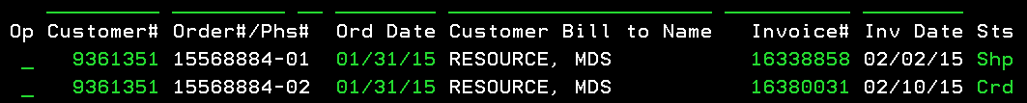

If you will review the credit phase with a “5” you will see this screen:

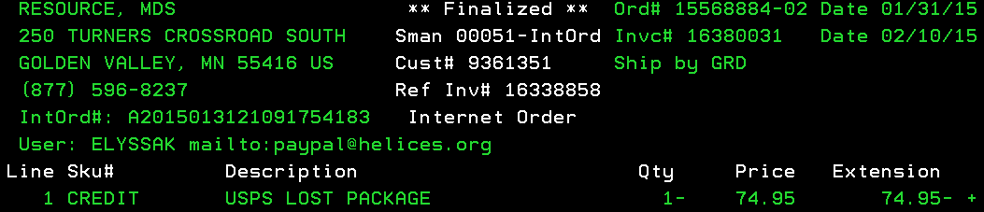

Just below the internet order number, you will see who issued the refund/credit. You will also see a + sign on the amount. It means that it has a line item note. To read the note, point your cursor on the line and hit SHIFT+F2 and you will see this:

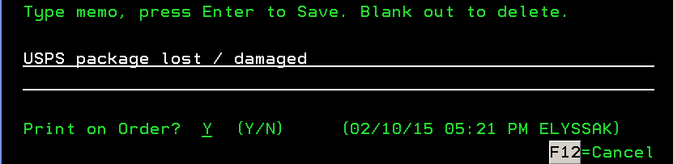

This will give you an idea as to why we issued a credit/refund. In order for you to verify if the money was refunded back to the original funding source, hit F7 (Pay Info) on the order entry system. You will see this:

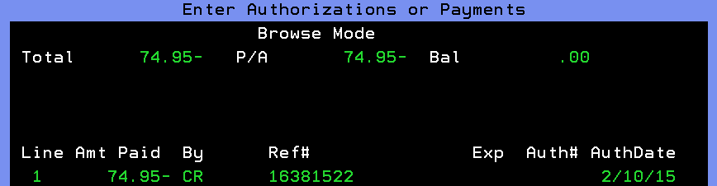

CR means CREDIT. In Adorama, when we say credit we refer to a store credit or funds available. It means that the money was not refunded back to the original funding source. If the credit is still available, you will see the amount on the balance section. If you are seeing reference #, it means that the store credit was used on that order/invoice #.

If the money was refunded back to CC, it will show CC paid and the last 4 digits of the card where it was issued to.

* PayPal funded orders

If the money was refunded back to PP, you might see PP pending or PP paid. If you saw PP pending, it means that our system didn’t automatically refund the money back to PP that is why we will be refunding it manually. To verify if the refund was successfully issued, check F22 notes. If there is a PP transaction ID on the notes, then the refund went through.

* 3rd party orders

If the order was made through Amazon, NewEgg or Rakuten, FlexShopper, you will see AP/AC, NP/NC, BP/BC. P stands for payment and c stand for commission. If the customer claims that they haven’t received their refund yet, advise them to contact their payment source.

* Orders funded by GC/CP

If an order funded by GC or CP was returned, the money will be issued as a credit/FA. If the order was partially funded by GC/CP and the rest was PP, CC or V.Me etc, the amount that was taken out from those funding sources will be refunded and the amount of the GC will be issued as FA.

* FA to funding source

FA/Store credit can be refunded back to the original funding source used by the customer. However, FA issued for warranty return and returned item funded by GC/CP cannot be requested to be credited to a CC or PP. To request for the FA to be refunded, we open a note to *CREDITS.

**Refund Status - Reshipment Order**

If the customer returned a reshipment order funded by FA, check the funding source of the original order.

If the funding source is CC and the customer wanted the money to be refunded back, the system can automatically do it.

If the funding source is V.me, PayPal Credit and Flex Shopper, the same process will not work. The only way that we can give their money back is through check which would take 2 weeks.

To request for a check to be sent to their billing address, we open a note to *CREDITS.

To request for a check to be sent to a different address, we email sabrinaa.

***Additional Notes:***

**Return and Exchange Process**

2017